**BT307 LAB 2**

**1) Name:** Aditya Jindal

**2) Roll No.:** 210106004

**3)** I am using data1.csv.

**4)** 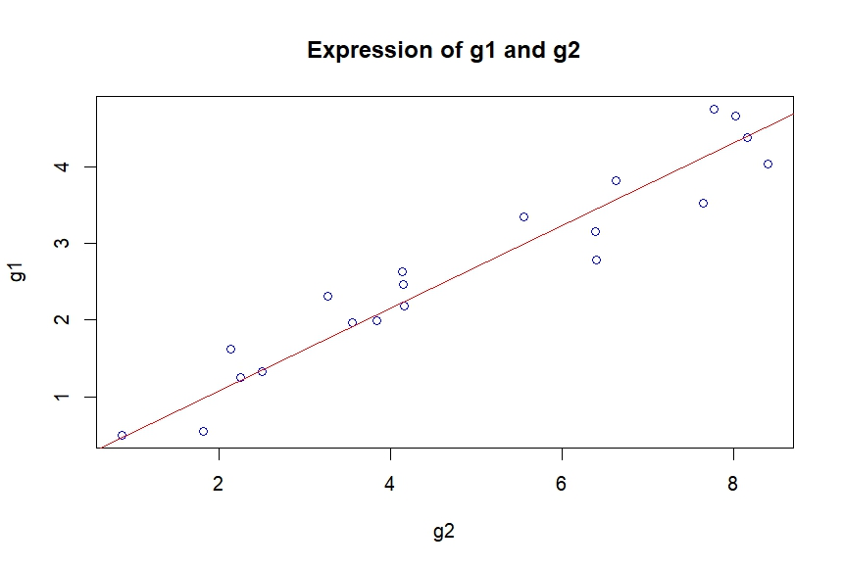

**5)**

m = 0.53897

g1 = 0.53897*g2

**6)** R-squared: 0.9845

**7)** p-value: < 2.2e-16

**8)**

For reduced model:

lm(formula = y ~ x + 0, data = data)

Residuals:

Min 1Q Median 3Q Max

-0.67069 -0.13067 0.03376 0.34123 0.55845

Coefficients:

Estimate Std. Error t value Pr(>|t|)

x 0.53897 0.01553 34.71 <2e-16 ***

---

Signif. codes: 0 ‘***’ 0.001 ‘**’ 0.01 ‘*’ 0.05 ‘.’ 0.1 ‘ ’ 1

Residual standard error: 0.3761 on 19 degrees of freedom

Multiple R-squared: 0.9845, Adjusted R-squared: 0.9837

F-statistic: 1205 on 1 and 19 DF, p-value: < 2.2e-16

For whole model:

lm(formula = y ~ x, data = data)

Residuals:

Min 1Q Median 3Q Max

-0.65981 -0.17258 -0.03795 0.34050 0.60689

Coefficients:

Estimate Std. Error t value Pr(>|t|)

(Intercept) 0.16492 0.19600 0.841 0.411

x 0.51151 0.03618 14.136 3.46e-11 ***

---

Signif. codes: 0 ‘***’ 0.001 ‘**’ 0.01 ‘*’ 0.05 ‘.’ 0.1 ‘ ’ 1

Residual standard error: 0.379 on 18 degrees of freedom

Multiple R-squared: 0.9174, Adjusted R-squared: 0.9128

F-statistic: 199.8 on 1 and 18 DF, p-value: 3.462e-11

I chose the reduced model as the p-value in the reduced model(p-value: < 2.2e-16) is smaller than the whole model(p-value: 3.462e-11).